|  |
| --- |
| NYC Restaurant Inspection Analysis Tool Executive Summary |
| Liangxian Zhao s2869753 and Rafael Alexander s52771572810ICT Software TechnologiesOctober 9, 2022 |

# Abstract

The program was able to showcase analyzation and visualization results respective of its feature: 1. Inspection Details (Time), Violation Keyword and Inspection Details (Borough) features showcasing analyzation of data through tables and 2. Violation Distribution and Animal Related Cases features showcasing visualization of distribution and trends, respectively. Within the selected date range and in both cases, Manhattan proves to be the borough with most violation cases, both overall and mice-related cases, irrespective of number of restaurants in each borough. But it is also important to note that Manhattan, along with Staten Island, showed a decrease in mice-related cases in contrast to the other boroughs.

# Introduction

This report focuses on the program created in the Software Technology course' assignment and aims to demonstrate and show the analysis/visualisation results for each respective feature of the program. The program is made to analyze and visualize data from the New York Restaurant Inspection results dataset provided. We deemed the name, NYC Restaurant Inspection Analysis Tool, appropriate for the program. The features provided within this tool are: 1. Inspection Details (Time): for a user-selected period, retrieve relevant inspection details, 2. Violation Distribution: for a user-selected period, plot the distribution of violations over the different suburbs, 3. Violation Keyword: for a user-selected period, retrieve all violations that contain a keyword (user entered), 4. Animal Related Cases: analyze the cases related to animals (rats and mice) and their trend over time and distribution over suburbs, and 5. Inspection Details (Borough): for a user-selected borough, retrieve relevant inspection details. For the purposes of this report, the date range covered chosen will be 1 June 2014 - 1 June 2015, which covers a 12 month period.

# **Inspection Details (Time)**

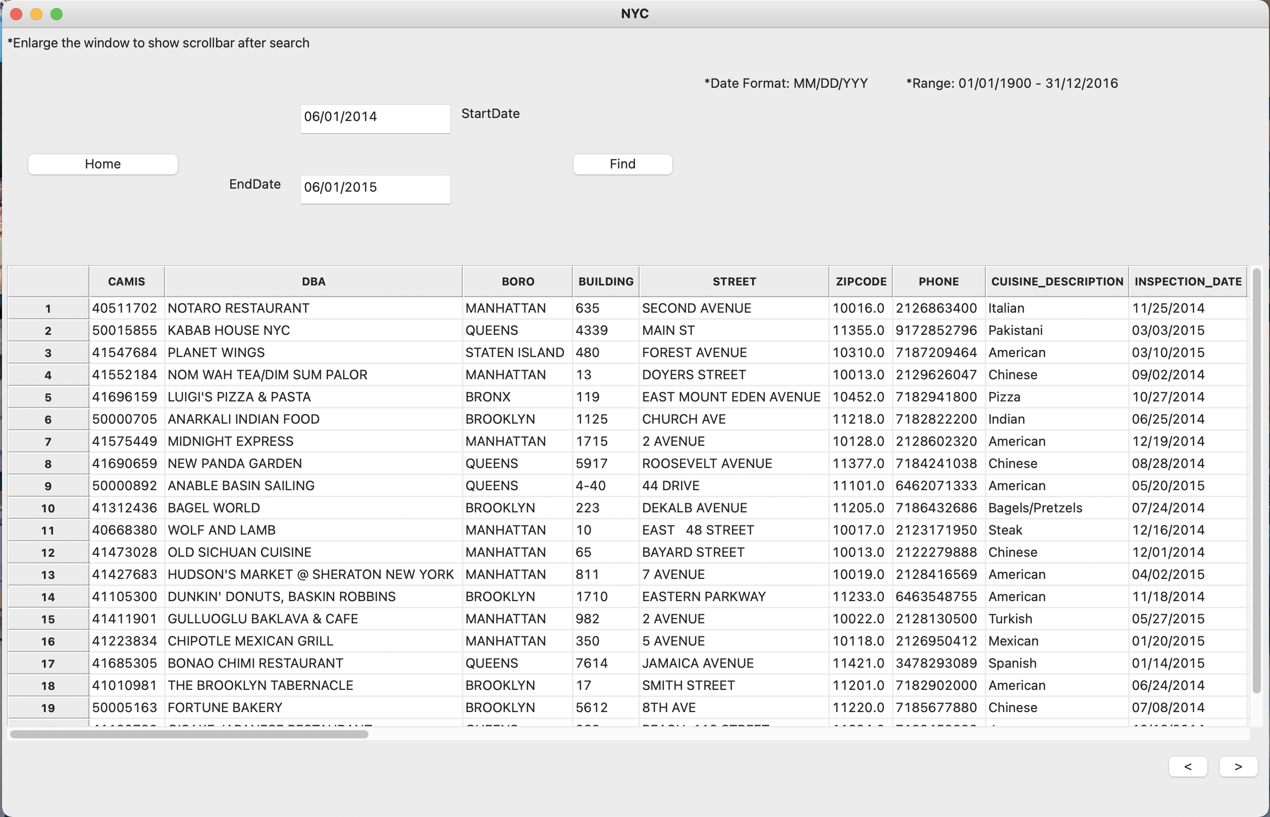

The above image showcases the program's results for the aforementioned date range (1 June 2014 - 1 June 2015) for the Inspection Details (Time) feature that for a user-selected period, retrieve relevant inspection details. It shows all the details of all inspections in NYC within the date range with the default order from the dataset.

# **Violation Distribution**

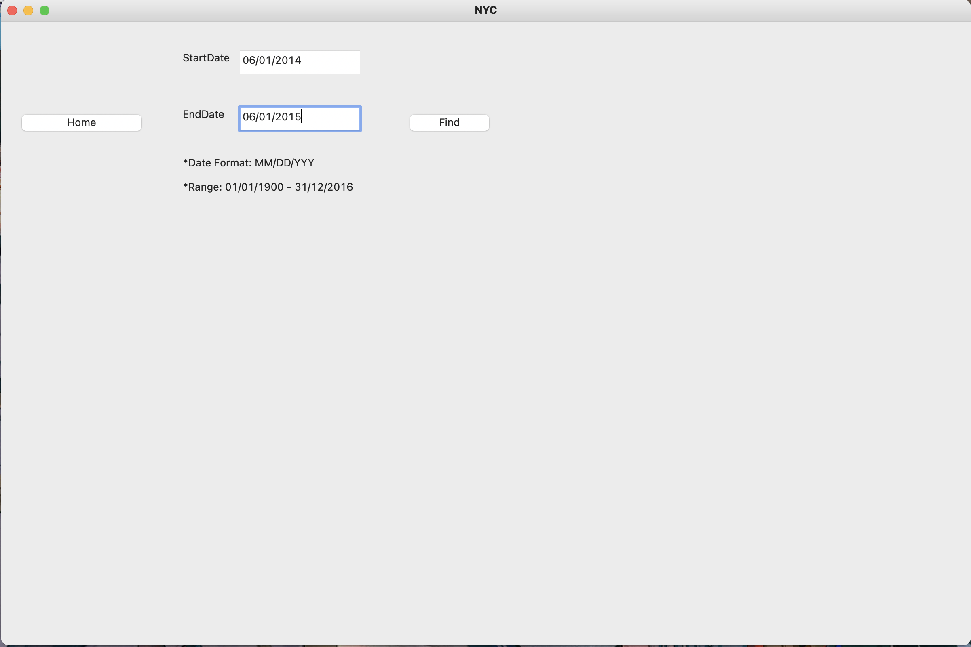.

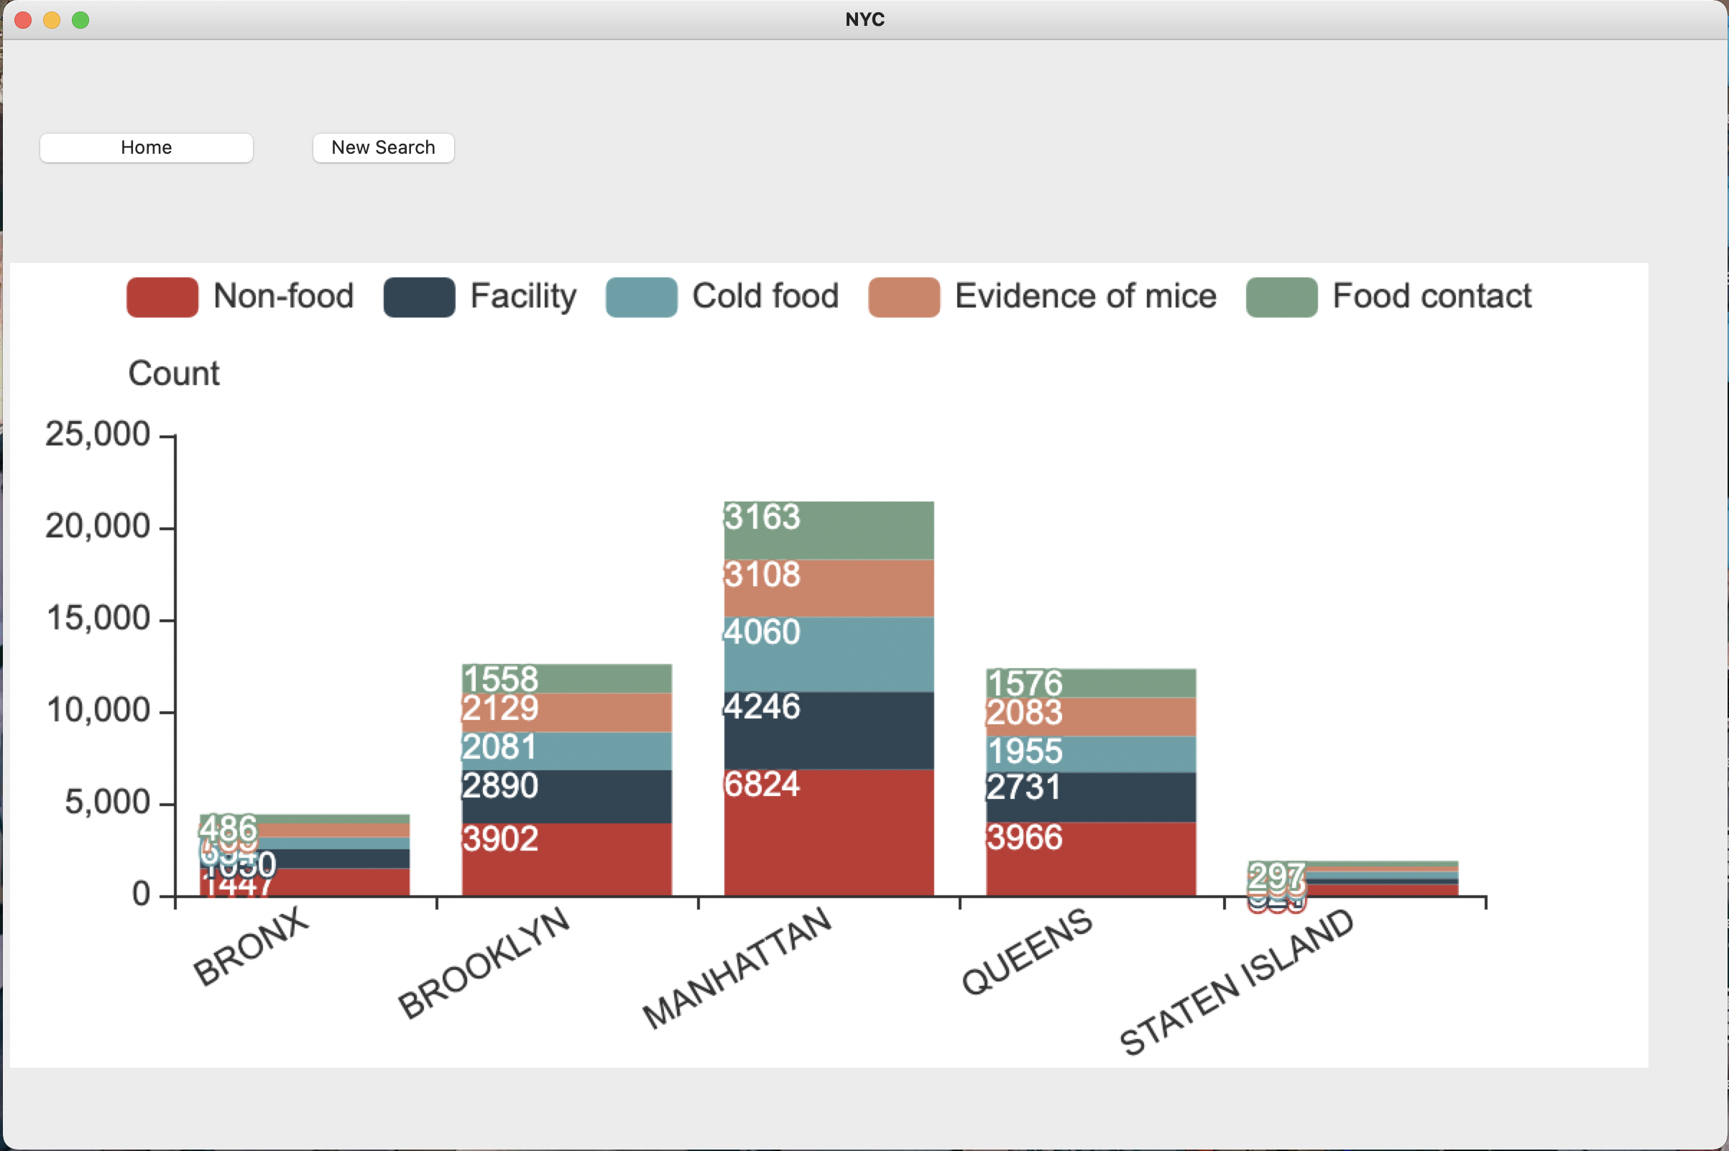

The above image showcases the program's visualization result for the aforementioned date range (1 June 2014 - 1 June 2015) for the Violation Distribution feature that for a user-selected period, plot the distribution of violations over the different suburbs. It visualizes the type of violation in each suburb and its distribution (through violation count). The type of violations determined for this scope of this program are: non-food, facility related, cold food, evidence of mice and food contact related violations. From the above results we can conclude a couple of things: 1. From the date range of 1 June 2014 - 1 June 2015, Manhattan has the most number of violations irrespective of restaurant amount for each suburb and 2. Non-food related violation is the most common violations in each suburb.

# **Violation Keyword**

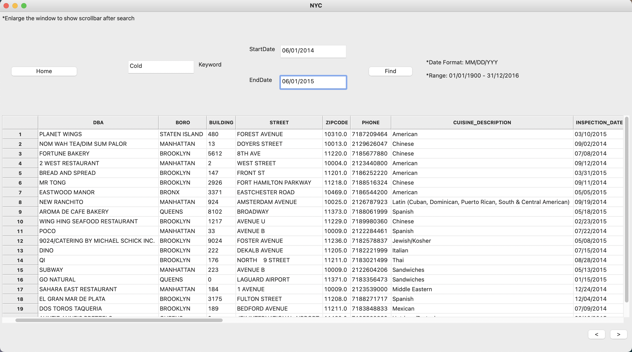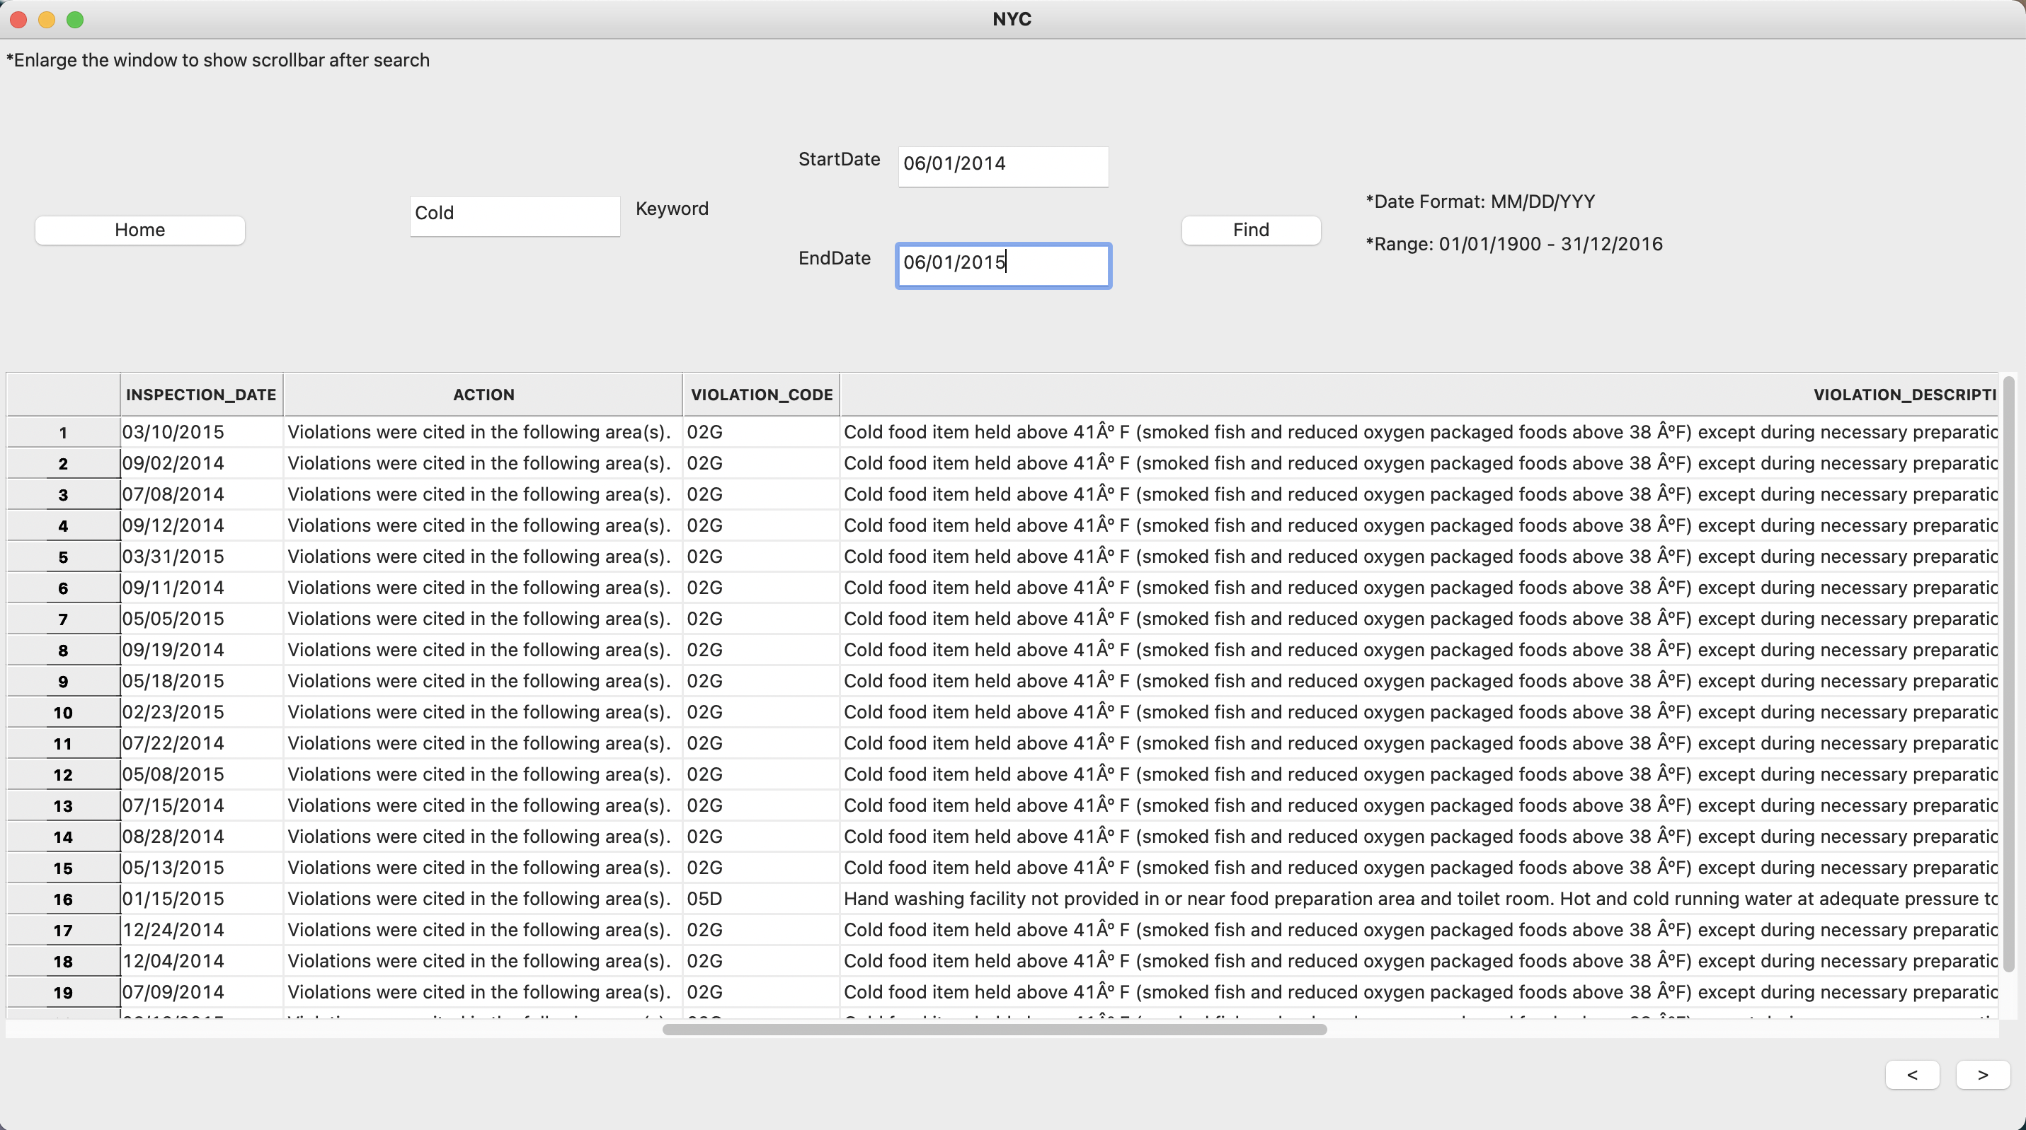

The above image showcases the program's results for the aforementioned date range (1 June 2014 - 1 June 2015) for the Violation Keyword feature that for a user-selected period, retrieve

all violations that contain a keyword (user entered). It shows all the details of all inspections in NYC within the date range and whose violation description contains the user-entered keyword, in this case "Cold", with the default order from the dataset. The results shows all inspection results with the keyword cold irrespective of where its position is in the violation description.

# **Animal Related Cases**

. 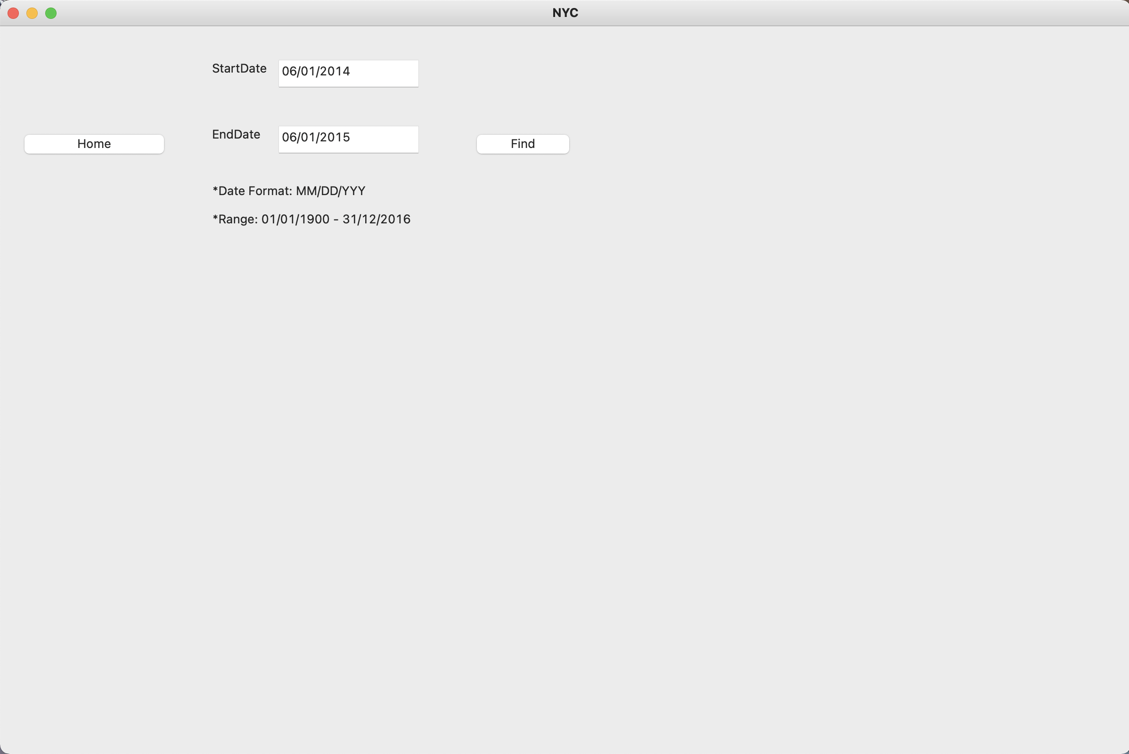

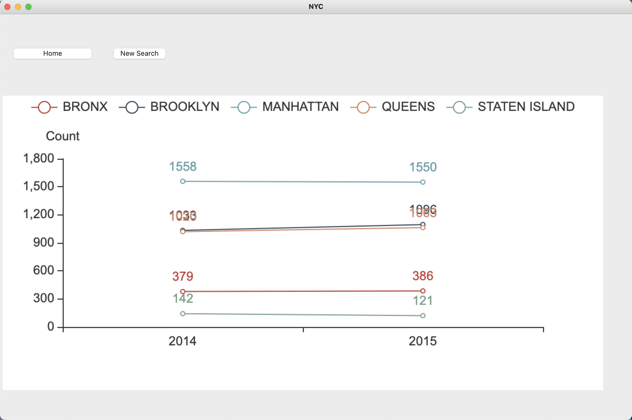

The above image showcases the program's visualization result for the aforementioned date range (1 June 2014 - 1 June 2015) for the Animal Related Cases feature that analyzes the cases related to animals (rats and mice) and their trend over time and distribution over suburbs. The time checkpoints determined in the scope of this program is annually. From the above results we can conclude a couple of things: 1. Manhattan and Staten Island had a decrease in animal related cases (rats and mice) within the date range with Manhattan having a slight decrease (by 8 cases) and Staten Island having a larger decrease (21 cases) 2. Bronx, Brooklyn and Queens had an increase in animal related cases (rats and mice) within the date range with Brooklyn having the highest increase (63 cases) and Bronx with the lowest increase (7 cases) that leaves Queens in the middle with 43 cases.

# **Inspection Details (Borough)**

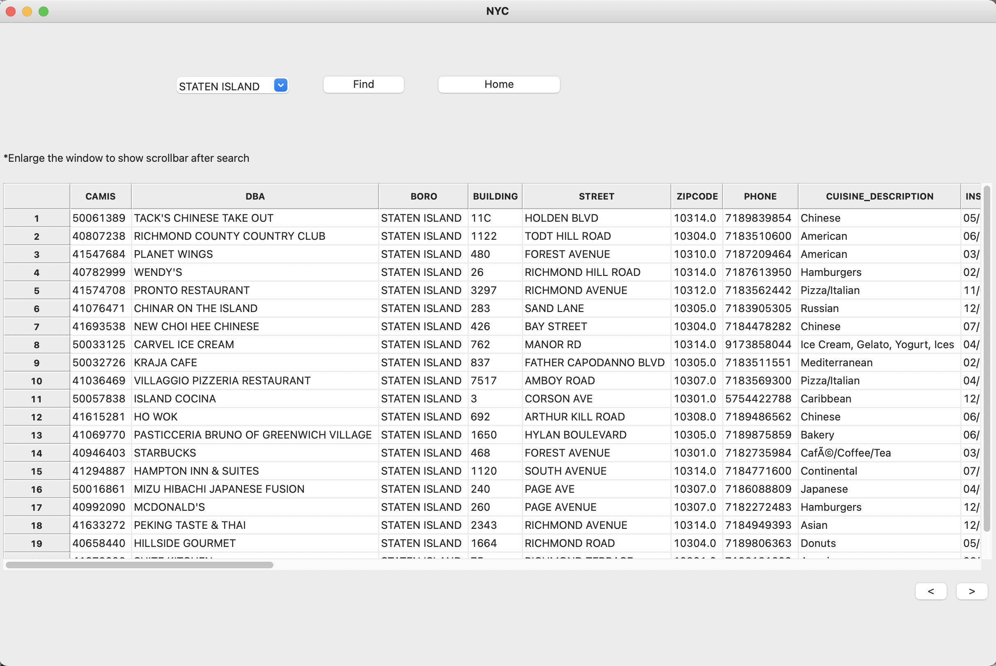

The above image showcases the program's results for the aforementioned date range (1 June 2014 - 1 June 2015) for the Inspection Details (Borough) feature that for a user-selected borough, retrieve relevant inspection details. It shows all the details of all inspections in NYC within the borough with the default order from the dataset. Date range for inspection results is not within the scope of this program's feature as stated in previous documents.